**Q.1 Declare an interface called function that has method name evaluate, that takes an int. parameter and returns an integer value. Create a class called half that implements the above interface. The implementation of the method evaluate should return the value obtained by dividing the integer arguments by 2.**

import java.util.*;

interface function{

public int evaluate(int num);

}

class half implements function{

public int evaluate(int num){

return num/2;

}

}

class Demo{

public static void main(String args[]){

Scanner sc=new Scanner(System.in);

System.out.println("Enter Number : ");

int num=sc.nextInt();

half h=new half();

System.out.println("The half value of given number : "+h.evaluate(num));

}

}

**Output :**

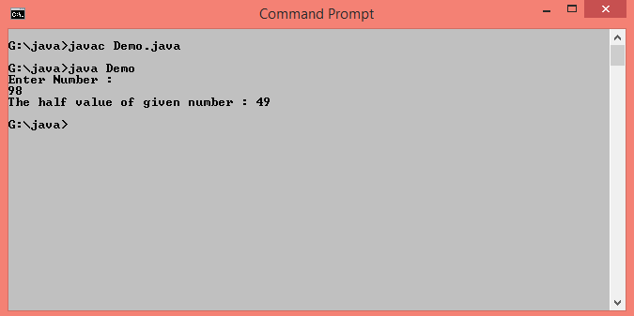

**Q.2 Write class student and store it into a package. Write a class batch with information about subject, faculty and timing. Store it in package bat. Use batch class to set information in student class.**

**//Student class**

package mypack;

public class Student{

int age;

String sex;

String name;

public Student(String n,int a,String s){

name=n;

age=a;

sex=s;

}

public void display(){

System.out.println("Student Information");

System.out.println(" Name : "+name+"\n Age :"+age+"\n Sex : "+sex);

}

}

**//Batch class**

import mypack.*;

import java.util.*;

public class Batch{

public static void main(String args[]){

String faculty_name="Prof.Shweta Padale",subject="Java",name,sex;

Double d=10.00;

int age;

Scanner sc=new Scanner(System.in);

System.out.println("\n Enter name,age,sex of a student :");

name=sc.next();

age=sc.nextInt();

sex=sc.next();

mypack.Student s=new mypack.Student(name,age,sex);

s.display();

System.out.println("\n Faculty Information");

System.out.println(" Name : "+faculty_name+"\n Subject :"+subject+"\n Date and Time : "+d+"Am");

}

}

**Output :**

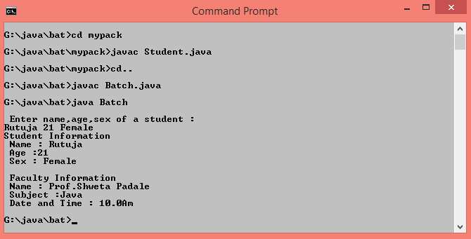

**Q.3 Write a program to create try block to create three types of exception and then incorporate necessary catch blocks to catch and handle them.**

class Exception{

void showException(){

try{

String s="Rutuja";

String s1=null;

int a[]=new int[10];

a[20]=100;

int n=Integer.parseInt(s);

System.out.println("Length of given String is "+s1.length());

}

catch(ArrayIndexOutOfBoundsException e){

System.out.println("Out of size");

}

catch(NullPointerException e){

System.out.println("Cannot calculate length of null string");

}

catch(NumberFormatException e){

System.out.println("Only number required");

}

}

}

class TryCatchDemo{

public static void main(String args[]){

Exception e1=new Exception();

e1.showException();

}

}

**Output :**

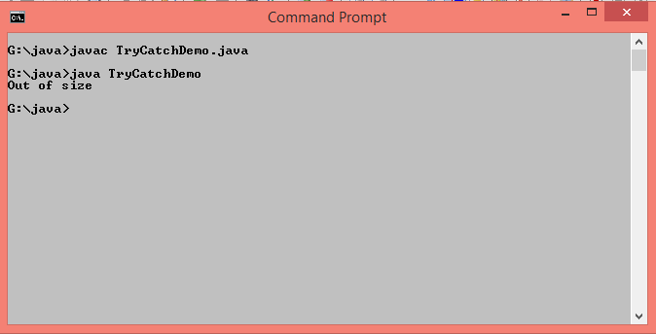

**Q.4 Write a program to implement finally block.**

import java.util.*;

class FinallyBlockDemo{

public static void main(String args[]){

int num1,num2,div;

Scanner sc=new Scanner(System.in);

try{

System.out.println("Enter Two numbers : ");

num1=sc.nextInt();

num2=sc.nextInt();

div=num1/num2;

System.out.println("Division= "+div);

}

catch(ArithmeticException ae){

System.out.println("Cannot divide by zero");

}

finally{

System.out.println("Rest of the code");

}

}

}

**Output :**

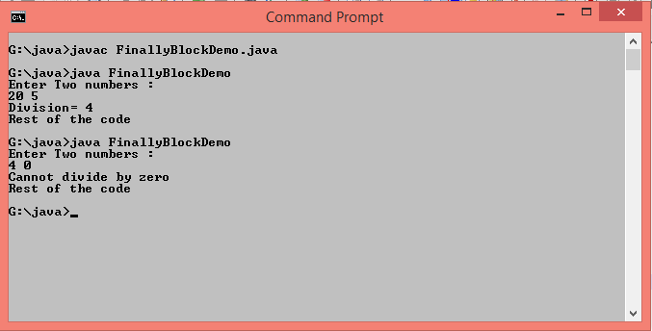

**Q.5 Write a program to accept marks for 3 subjects (Max. marks are 100 and min. Mark is 0). Implement exception handling for invalid marks.**

import java.util.*;

class StudentMarks extends Exception {

StudentMarks(String error)

{

super(error);

} }

public class MyException {

public static void main(String arg[]) {

try {

Scanner s=new Scanner(System.in);

System.out.print("Enter marks here : ");

int m1=s.nextInt();

int m2=s.nextInt();

int m3=s.nextInt();

if(m1<0 || m1>100 || m2<0 || m2>100 || m3<0 || m3>100) {

throw(new StudentMarks("Invalid marks"));

}

System.out.print("Entered marks are : " +m1+" "+m2+" "+m3);

}

catch(InputMismatchException e) {

System.out.println("Invalid Input..Pls Input Integer Only..");

}

catch(StudentMarks e) {

System.out.println("Error:"+e);

} } }

**Output :**

